(Date)
Dear (Name),

(Our organization) is currently working with Miami University on a new quality improvement initiative called PAL Cards. PAL Cards are personalized 5x7 laminated cards that will reflect your loved one’s recreation and leisure preference information. PAL Cards will aid our staff in personalizing care, and help foster relationships among residents, family, and care team members. An individual’s PAL Card can be displayed on their wheelchairs or walkers, in their rooms, or on their doors in order to spark conversation with fellow residents as well as with our staff.

The front of each PAL Card includes the resident’s name and a short biography. The back of the card is personalized to highlight the resident’s important preferences. The sections on the back will vary depending on the unique interests of each resident, such as family, favorite activities (e.g. Sunday drives, flea markets), music, former employment, hobbies, religious beliefs, or anything else to start a meaningful conversation. PAL Cards will help when a resident may get agitated, mad, sad, etc., as staff can read their card to quickly find a topic that will spark joy.

However, we need more information to complete a PAL Card for your loved one. We are hoping that you can send along some information you think your loved one would want others to know about themself. You do not have to write paragraphs on each item- just a general idea of favorites will suffice.

I have enclosed a copy of a sample PAL Card to give a better idea of what the final product will look like, along with a list of questions that may help get you started.

Thank you so much for any information you provide!
If you have any questions, please call (Name) at (phone number/email address).

(Name)

Note: You can learn more about the PAL Cards at PreferenceBasedLiving.com.
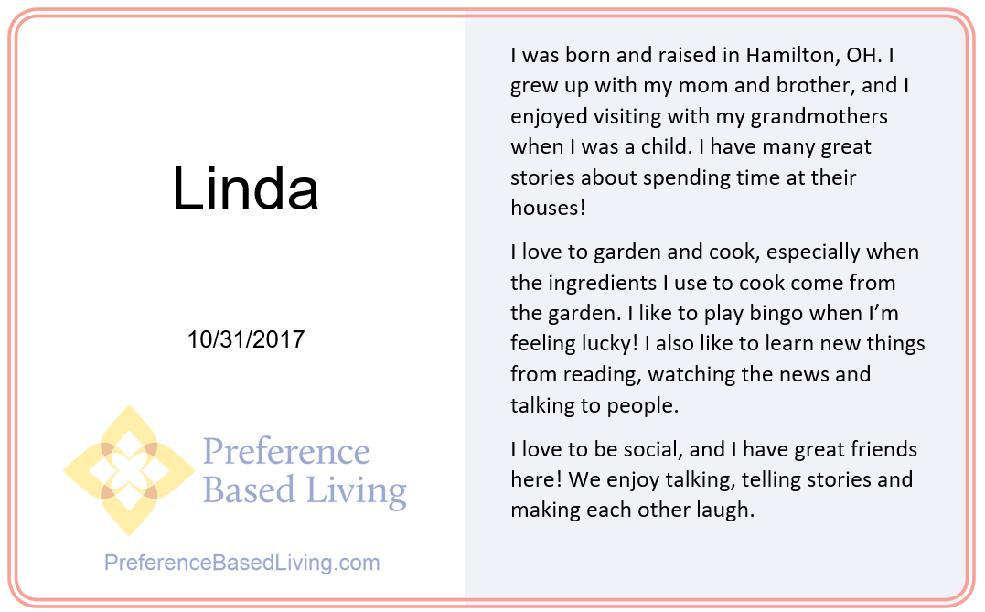
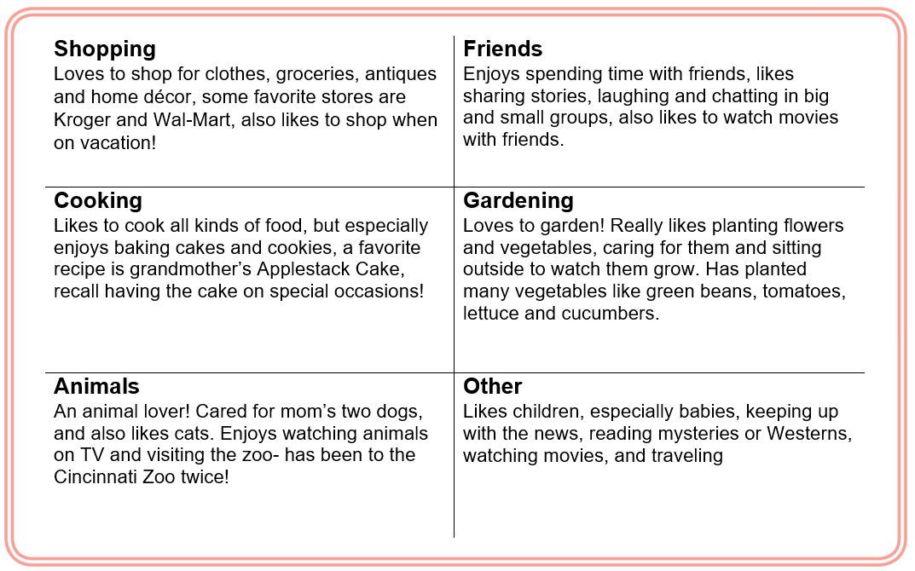
Questions
- What was your loved one’s childhood like? Do they have any special memories from childhood?
- What family and friends does your loved one have?
- Is your loved one social with others? If so, what kinds of activities do they like doing with others?
- Are there any outdoor activities your loved one enjoys?
- What activities does your loved one enjoy doing in their spare time?
- Does your loved one have any hobbies?
- Did your loved one have a former job or career that was important to them?
- Are there any animals or pets your loved one likes to spend time with?

