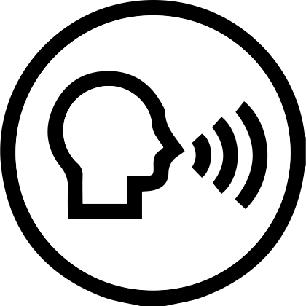 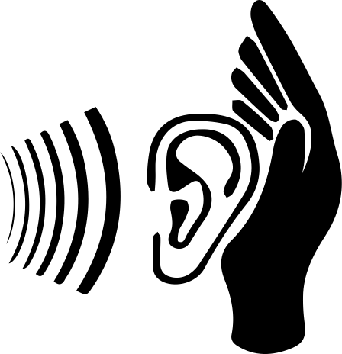      

**Preference Here**

Brief description here

**Communication Preferences**

Speak to me. Modification not needed.

Increase your volume but don’t yell. I will understand you better if you use a lower pitch.

When communicating with me, I prefer to wear my hearing aids.

When communicating with me, print key words or phrases in large letters.

When speaking to me, use simple gestures to represent key words.

Use simple pictures to help me understand you and make choices.

When communicating with me, make sure I have my glasses.

Verbalize your actions and provide visual information in an alternative way (audio, large print, or braille).

**Preference Here**

Brief description here

**Preference Here**

Brief description here

**Preference Here**

Brief description here

**Preference Here**

Brief description here

Revised: (date)

Resident Bio Here

|  |
| --- |
| FIRST NAME HERE |